KV Nabha Cantt

WALK IN INTERVIEW

A panel for the academic year 2023-24 on part time cum contractual basis for the following posts is to be prepared. Eligible candidates should report in KV Nabha Cantt at 8:30 a.m along with Passport size photos and original & attested copies of certificates for interview. No TA/DA will be paid.

Post | Subject |  | Qualification
PGT | Economics |  | 1. Two year integrated post graduate M.SC. Course of Regional college of Education of NCERT in the concerned subject .  Or  Master degree from a recognized university in concerned subject with 50% Marks in aggregate in the subject Economics/Applied Economics/ Business Eco.  2. B.Ed.or equivalent degree from a recognized university  3. Proficiency of teaching in English medium.  Note: Candidates having special B.Ed are not eligible for the post of PGT  . Desirable : knowledge of Computer Application
PGT | COMMERCE |  | 1. Two year integrated post graduate M.SC. Course of Regional college of Education of NCERT in the concerned subject .  Or  Master degree from a recognized university in concerned subject with 50% Marks in aggregate in the subject Commerce. However, holder of Degree of M.Com in Applied/ Business Economics shall not be eligible.  2. B.Ed.or equivalent degree from a recognized university  3. Proficiency of teaching in English medium.  Note: Candidates having special B.Ed are not eligible for the post of PGT  . Desirable : knowledge of Computer Application
PGT | English |  | 1. Two year integrated post graduate M.SC. Course of Regional college of Education of NCERT in the concerned subject .  Or  Master degree from a recognized university in concerned subject with 50% Marks in aggregate in the subject.  2. B.Ed.or equivalent degree from a recognized university  3. Proficiency of teaching in English medium.  Note: Candidates having special B.Ed are not eligible for the post of PGT  . Desirable : knowledge of Computer Application
PGT | Hindi |  | Two year integrated post graduate M.SC. Course of Regional college of Education of NCERT in the concerned subject .  Or  Master degree from a recognized university in concerned subject with 50% Marks in aggregate in the subject Hindi or Sanskrit with hindi as one of the subject at graduate level  2. B.Ed.or equivalent degree from a recognized university  3. Proficiency of teaching in Hindi medium.  Note: Candidates having special B.Ed are not eligible for the post of PGT  . Desirable : knowledge of Computer Application
PGT | Maths |  | 1. Two year integrated post graduate M.SC. Course of Regional college of Education of NCERT in the concerned subject  .Or  Master degree from a recognized university in concerned subject with atleast 50% Marks in aggregate in mathematics/applied mathematics  2. B.Ed.or equivalent degree from a recognized university  3. Proficiency of teaching in English and Hindi medium.  Note: Candidates having special B.ed are not eligible for the post of PGT  . Desirable : knowledge of Computer Application
TGT | Maths |  | - Four Years integrated course of Regional College of education of NCERT in the concerned subject with at least 50% marks in aggregate  or  Bachelor’s degree with at least with 50% Marks in the concerned subject/  combination of subjects and in aggregate. The elective subjects and languages in the  combination of subjects are as under:  Bachelor degree in Maths with any two of the following subjects:- Physics, Chemistry , Electronics, Computer Science , Statistics  - B.Ed. from recognized university  - Pass in the CTET –Paper-II conducted by CBSE.  - Proficiency of teaching in English and hindi medium  5. The candidate should have studied Maths in all the years of graduation with any two subjects out of Physics, Chemistry, Electronics, Computer Science, Statistics.  6. In case of Honours Degree in Maths, the candidate should have studied Maths in all the years of graduation with atleast 50% marks in aggregate and any of the two subjects indicated in point No.1 above with atleast 50% marks in each subject at graduation, level and also atleast 50% marks in graduation,.  7. BA (Hons.) in Maths and B.Sc (Hons) in any subject other than Maths are not eligible for the post of TGT (Maths).  Desirable : knowledge of Computer Application
TGT | Hindi |  | - Four Years integrated course of Regional College of education of NCERT in the concerned subject with at least 50% marks in aggregate  or  Bachelor’s degree with at least 50% Marks in the concerned Subject/ combination of subject and in aggregate with Hindi as a subject in all three years.  - B.Ed from recognized university  3. Pass in the CTET –Paper-II conducted by CBSE
TGT | Sanskrit |  | 1.Four Years integrated course of Regional College of education of NCERT in the concerned subject with at least 50% marks in aggregate  or  Bachelor’s degree with at least 50% Marks in the concerned Subject/ combination of subject and in aggregate with Sanskrit as a subject in all three years.  2.B.Ed from recognized university  3. Pass in the CTET –Paper-II conducted by CBSE  Desirable : knowledge of Computer Application
TGT |  | Punjabi |  | - Four Years integrated course of Regional College of education of NCERT in the concerned subject with at least 50% marks in aggregate  or  Bachelor’s degree with at least 50% Marks in the concerned Subject/ combination of subject and in aggregate with Punjabi as a subject in all three years.  2 .B.Ed from recognized university  3. Pass in the CTET –Paper-II by CBSE  Desirable : knowledge of Computer Application
TGT | Science |  | - Four Years integrated course of Regional College of education of NCERT in the concerned subject with at least 50% marks in aggregate  or  Bachelor’s degree with at least with 50% Marks in the concerned subject/  combination of subjects and in aggregate. The elective subjects and languages in the combination of subjects are as under:  Botany, Zoology and Chemistry.  - B.Ed from recognized university  - Pass in the CTET –Paper-II Conducted by CBSE  - Proficiency of teaching in English and hindi medium  5.The candidate should have studied Botany, Zoology and Chemistry in all the years of graduation with atleast 50% marks in each subject.  6. The candidates with Honours Degree in Botany/Zoology/Chemistry with atleast 50% marks in B.Sc should have studied other two subjects with atleast 50% marks in each of them at graduation level.  Desirable : knowledge of Computer Application
TGT | Social Science |  | - Four Years integrated course of Regional College of education of NCERT in the concerned subject with at least 50% marks in aggregate  or  Bachelor’s degree with at least 50% Marks in the concerned Subject/ combination of  subject and in aggregate with Sanskrit as a subject in all three years.  2. B.Ed from recognized university  - Pass in the CTET –Paper-II Conducted by CBSE  - Proficiency of teaching in English and hindi medium  5. The candidate should have studied any two subjects out of the following:  (i) History with atleast 50% marks in aggregate and one subject out of Geography/Economics/Political Science with atleast 50% marks in aggregate and also atleast 50% marks in graduation,  OR  (ii) Geography with 50% marks with History/Economics/Political Science with atleast 50% marks in aggregate and also atleast 50% marks in graduation.  6. Geography/History should have been studied in all the years of graduation with atleast 50% marks.  7. In case of Honours Degree in History, the candidate should have studied Geography/Economics/Political Science in first and/or second year of graduation with at least 50% marks in History in aggregate and at least 50% marks in other subject indicated above at graduation level and also at least 50% marks in aggregate at graduation level.  8. Similarly in case of Honours degree in Geography, the candidate should have studied History/Economics/Political Science in first and/or second year of graduation with at least 50% marks in Geography in aggregate and atleast 50% marks in other subject indicated above at graduation level and also atleast 50% marks in aggregate at graduation level.  Desirable : knowledge of Computer Application
Coach (Sports) |  |  | Bachelor Degree in Physical Education (B.P.Ed.) or equivalent. With 50% Marks
PRT | - |  | 1.Senior Secondary School certificate or Intermediate with 50% Marks or its equivalent  2.Two years Diploma in Education (D.Ed.) or Bachelor in Elementary Education (B.El.Ed) / E.T.T/J.B.T. or its equivalent  3. Pass in the CTET- Paper -I conducted by CBSE  4 Proficiency of teaching in English and hindi medium  Desirable : knowledge of Computer Application  Note :The candidates having professional qualification B.Ed/ B.Ed (Special Education) are not eligible for the post of primary teacher.
Nurse |  |  | Three year Diploma in Nursing from any institution recognized by the Medical Council of India or State (Desirable-Basic Life Support Course at least once in two years)  Desirable : knowledge of Computer Application

Special Educator
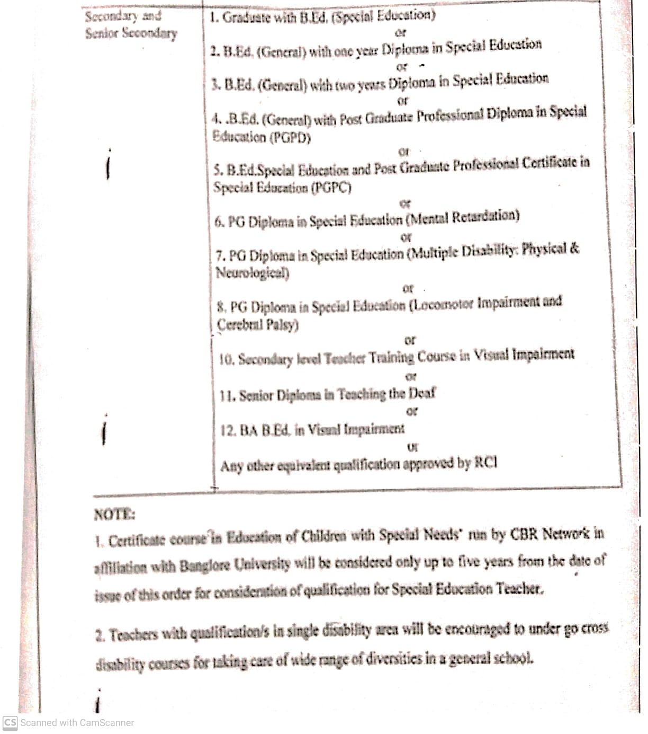Note :
- Age limit is 18-65 years.
- Emoluments as per KVS rules.
- Knowledge of Computer Application.
- Proficiency of teaching in English and hindi medium

